|  |  |  |
| --- | --- | --- |
| **Report IDM reference No.** | *EFDA_D_2 LDAFV* | **Version: see IDM** |

Final Report

on Deliverable

*MAT-1.3.2-T3-D1 Status Report on Development of Rules for Creep-Fatigue (KIT)*

|  |  |  |  |
| --- | --- | --- | --- |
|  | | **Deliverable-ID**[1] | *MAT-1.3.2-T3-D1* |
| **Work Package** | *WPMAT* | **Date** | *31. October 2015* |
| **Project Leader** | *Michael Rieth* | | |
|  | | | |
| **TS Title** | *EDDI Structural Design Criteria – Priority Gaps – Creep-Fatigue* | | |
| **TS Ref. No.** | *EDDI-1.3.2-03* | **TS IDM-link** | *EFDA_D_2LDAFV* |
| **Task Owner** | *Jarir Aktaa* | | |
| **RU(s)** | *KIT* | | |

|  |  |
| --- | --- |
| **Report Review & Approval** | |
| **IDM role** | **Name(s)** |
| **Author** | *Jarir Aktaa* |
| **Co-author(s)** |  |
| **Reviewer(s)** | *Mani Kalsey, Mike Gorley* |
| **PMU Reviewer** | *Eberhard Diegele* |
| **Approver** | *Michael Rieth* |

|  |  |  |  |  |  |
| --- | --- | --- | --- | --- | --- |
| x | Study / Assessment |  | Procurement / Commissioning of Hardware |  | Industry |

|  |  |  |  |
| --- | --- | --- | --- |
|  | Use of Facility |  | Other *{please specify}* |

|  |
| --- |
| **Executive Summary** |
| A test matrix for creep tests on pre-fatigued specimens has been proposed for generating the material design data required for the application of the modified creep-fatigue rules. The efforts for the tests have been minimized by utilizing the Monkman-Grant relationship and its independence on pre-cyclic deformation and cyclic softening, respectively. For easy implementation of the modified creep-fatigue rules in already existing structural design codes simplifications of the modified rules have been introduced. |

|  |
| --- |
| **Comments** (shortcomings, deviations, etc.) |
|  |

**Table of Contents**

1 Introduction and Objectives of Work 3

2 Description of Work 3

3 Conclusion 7

4 References 7

**Abbreviations**

|  |  |
| --- | --- |
| ASME-BPV | American Society of Mechanical Engineers – Boiler and Pressure Vessel |
| RCC-MR | Design and Construction Rules for mechanical components of nuclear installations |

# Introduction and Objectives of Work

The aim of the work is the development of creep-fatigue design rules for the ferritic martensitic steel EUROFER. Cyclic softening of ferritic martensitic steel and its impact on creep strength are identified as the main reason for the strong non-linear creep-fatigue interaction evaluated using conventional creep-fatigue rules. Therefore a modification has been proposed for the creep-fatigue accumulation rule by ASME-BPV and RCC-MR codes in which the influence of cyclic softening on creep rupture time shall be taken into account. The application of this modification requires creep rupture lifetimes measured in creep tests performed on pre-cycled and thus pre-softened specimens. To provide these additional material design data a test programme shall be initiated elaborating a proper test matrix. Performing this test matrix shall have a high priority in order to be able to quantitatively evaluate the potential enhancements expected when using the modified creep-fatigue rules. However the modified rules shall be prepared for the DDC providing simplified clear steps for their implementation.

# Description of Work

Based on the assessment performed in 2014 for the applicability of the creep-fatigue accumulation rules of the ASME-BVP and RCC-MR codes to 9-Cr steels the following modification of this rules has been proposed [1]:

* Calculation of creep damage portion in the creep fatigue accumulation rule in
  1. first 10% of the lifetime using *Si* from monotonic stress strain curves and design creep curves of as received material assuming no effect of cyclic softening on stress-to-rupture curves
  2. remaining 90% of the lifetime using *Si* from cyclic stress strain curves and design creep curves of cyclic softened material
* Using allowable total creep fatigue damage values of RCC-MR for SS 316 and Grade 91 - envelope with (0.3,0.3) tip point.

The application of this modification requires material data not yet available for EUROFER, in particular creep lifetime data for cyclic softened material. Due to cyclic softening accelerated creep and consequently shorter life time are expected. Quantitatively these effects will depend on the amount of cyclic softening which increases with increasing loading (strain) amplitude applied during cycling [2]. Therefore two strain amplitudes are selected in the test matrix elaborated for this type of experiments with which two levels of pre-softening shall be investigated (s. Figure 1 and Table 1). In the subsequent creep tests the stress was chosen based on the creep data available for EUROFER [3]. Thereby two types of tests are aimed, creep to failure and creep to minimum creep rate (s. Figure 1 and Table 1). The evaluation of both types will be carried out based on the Monkman-Grant relation [4] between minimum creep rate and creep rupture time which was found in similar investigations on other steels showing cyclic softening to be independent on pre-cycling and cyclic softening, respectively [4] (s. Figure 2). The creep tests to failure (1st type) will be used to verify for EUROFER the independence of the Monkman-Grant relationship on cyclic softening. With the verified Monkman-Grant relationship and the minimum creep rates of the 2nd type of creep tests the data base of creep lifetime on cyclic softened EUROFER can be than extended to longer lifetimes.

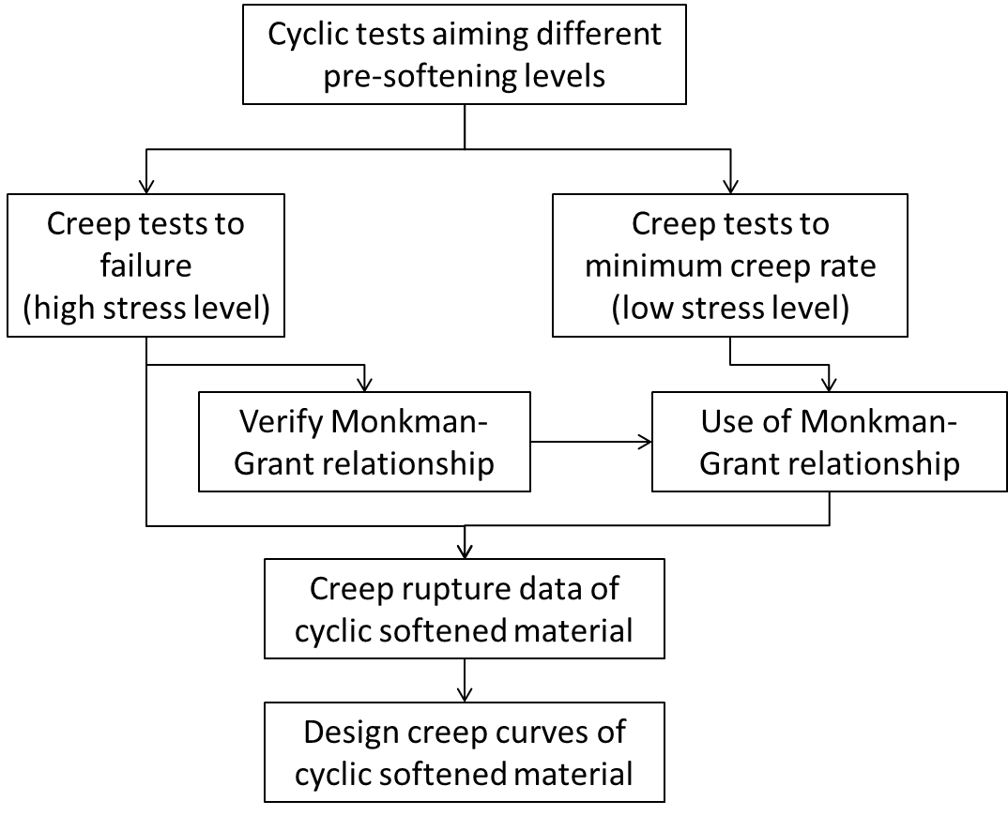

**Figure 1**: Flow chart of the experimental approach proposed for generating design creep curves of cyclic softened EUROFER

|  |  |  |  |  |
| --- | --- | --- | --- | --- |
|  | Pre-cycling | | Subsequent creep | |
| Temperature in °C | Strain range in % | Number of cycles | Stress in MPa | type |
| 550 | 0.4 | 2500 | 160 | minimum creep rate |
| 550 | 0.4 | 2500 | 180 |
| 550 | 0.4 | 2500 | 200 | failure |
| 550 | 0.4 | 2500 | 220 |
| 550 | 0.4 | 2500 | 240 |
| 550 | 1.0 | 250 | 160 | minimum creep rate |
| 550 | 1.0 | 250 | 180 |
| 550 | 1.0 | 250 | 200 | failure |
| 550 | 1.0 | 250 | 220 |
| 550 | 1.0 | 250 | 240 |

**Table 1**: Test matrix elaborated for the creep tests on prior cyclic softened EUROFER specimens

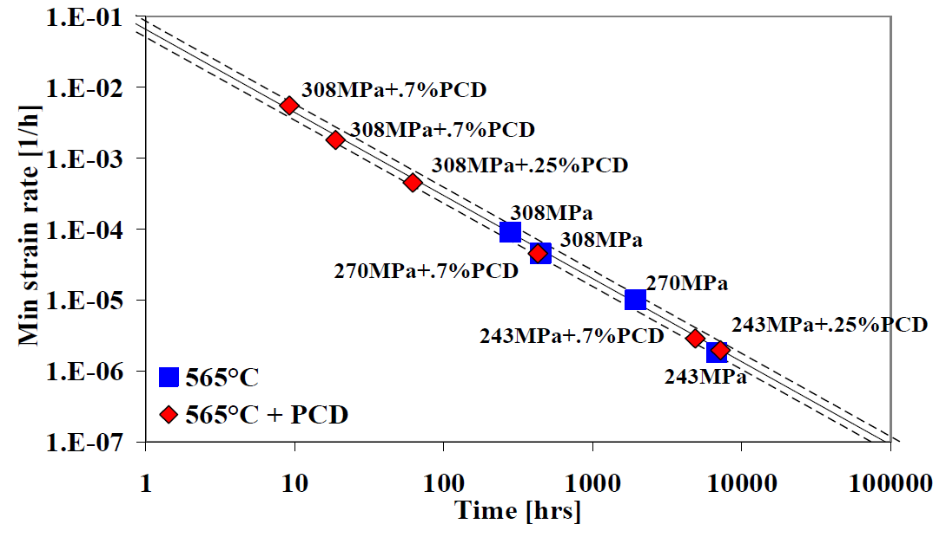

**Figure 2**: Monkman-Grant relation between minimum creep rate and creep rupture time for 1CrMoV steel and its independence on prior cycling deformation (PCD) and cyclic softening, respectively [4].

The temperature selected for the tests is 550°C which is the upper operation temperature for EUROFER and for which the largest material data base exists. It is also the temperature selected for the low cycle fatigue (LCF) tests with long hold times planned and proposed in [5] for verification of the new creep-fatigue rules. Evaluation of the creep data of EUROFER at this temperature [3] demonstrates in a double logarithmic plot of minimum creep rate, ${\dot{ε}}_{min}$ versus creep lifetime, $t_{CR}$ the applicability of the Monkman-Grant relationship (${\dot{ε}}_{min}∙ t_{CR}=const.$, s. Figure 3).

Having the creep lifetimes determined for EUROFER pre-softened to different levels, $ψ$ a cyclic softening stress factors, $K_{ψ}=f(ψ)$ will be then identified with which the stresses of design creep curves of as received material are reduced to obtain the design creep curves of cyclic softened material. With this simplification the modified creep-fatigue rules can be easily implemented by only introducing two calculation steps to the existing rules:

1. Determination of the cyclic softening level 𝜓 as function of total strain range and temperature by using monotonic and cyclic stress-strain curves.
2. Determination of the cyclic softening stress factor $K_{ψ}$ given as function of 𝜓 and applying it to the stress considered for calculating creep damage.



**Figure 3**: Monkman-Grant plot for EUROFER at 550°C, data from [3].

# Conclusion

A test matrix for creep tests on pre-fatigued specimens has been proposed for generating the material design data required for the application of the modified creep-fatigue rules. The efforts for the tests have been minimized by utilizing the Monkman-Grant relationship and its independence on pre-cyclic deformation and cyclic softening, respectively. For easy implementation of the modified creep-fatigue rules in already existing design codes and creep-fatigue assessment (CFA) tool developed in [7] simplifications of the modified rules have been introduced.

The planned activities for the next period will be focused on the collection and evaluation of the data to be generated performing the proposed tests as well as on the application of the modification proposed for the creep-fatigue accumulation rule to the creep-fatigue tests for verification.

# References

|  |  |
| --- | --- |
| [1] | J. Aktaa, „Creep-fatigue rules for EUROFER,“ EFDA_D_2L779C, 2014. |
| [2] | J. Aktaa and R. Schmitt, “High temperature deformation and damage behavior of RAFM steels under low cycle fatigue loading: Experiments and modeling,” vol. 81, pp. 2221-2231, 2006. |
| [3] | M. Rieth, M. Schirra, A. Falkenstein, P. Graf, S. Heger, H. Kempe, R. Lindau und H. Zimmermann, „EUROFER97 - Tensile, Charpy, Creep and Structural Tests,“ Scientific Report, FZKA 6911, Karlsruhe Institute of Technology, 2003. |
| [4] | F. C. Monkman und N. J. Grant, „Am empirical relationship between rupture life and minimum creep rate in creep-rupture tests,“ *Proc. ASTM,* pp. 593-620, Vol. 56, 1956. |
| [5] | L. Binda, Advanced creep damage and deformation assessment of materials subject to steady and cyclic loading conditions at high temperatures, ETH Zürich: PhD Thesis, 2010. |
| [6] | J. Cane and J. Aktaa, “Test Specification Eurofer LCF Long Hold Times,” EFDA_D_2LJDNQ v1.0, 2014. |
| [7] | M. Mahler und J. Aktaa, „Further creep-fatigue assessment tool development,“ EFDA_D_2MCDME, 2015. |

1. One *Deliverable Report* shall be submitted for each deliverable e.g. Study Report, Commissioning Report, Final Assessment Report, Technical Acceptance Report, Procurement Report, etc.